A MAJOR PROJECT REPORT
on

FIRE FIGHTING ROBOT USING ARDUINO WITH SMS ALERT
Submitted in partial fulfilment of the requirements for the award of the degree of

BACHELOR OF TECHNOLOGY
in

CSE (ARTIFICIAL INTELLIGENCE AND MACHINE LEARNING)
Submitted by
D.Likhitha Mahalaxmi (20UP1A6611)
G.Shravani (20UP1A6614)
M.Shruthi (20UP1A6632)
M.Sreeja (21UP5A6602)

Under the Guidance of
Mrs B.Sangeetha
Assistant Professor, M.Tech

DEPARTMENT OF CSE (ARTIFICIAL INTELLIGENCE AND MACHINE LEARNING)
VIGNAN’S INSTITUTE OF MANAGEMENT AND TECHNOLOGY FOR WOMEN
Accredited to NBA (CSE & ECE)
(Affiliated to Jawaharlal Nehru Technological University Hyderabad)Kondapur (Village), Ghatkesar (Mandal), Medchal (Dist.), Telangana Pincode-501301
2020-2024



VIGNAN’S INSTITUTE OF MANAGEMENTAND TECHNOLOGY FOR WOMEN

DEPARTMENT OF CSE (AI & ML)

CERTIFICATE

This is to certify that project work entitled “FIRE FIGHTING ROBOT USING ARDUINO WITH SMS ALERT” submitted by D.Likhitha Mahalaxmi (20UP1A6611), G.Shravani (20UP1A6614), M.Shruthi (20UP1A6632), M.Sreeja (21UP5A6602) in the partial fulfilment of the requirements for the award of the degree of Bachelor of Technology in CSE (Artificial Intelligence and Machine Learning)VIGNAN’S INSTITUTE OF MANAGEMENT AND TECHNOLOGY FOR WOMEN is a record of bonafide work carried by them under my guidance and supervision. The results embodied in this project report have not been submitted to any other University or institute for the award of any degree.

PROJECT GUIDE HEAD OF DEPARTMENT
Mrs. B. SANGEETHA Dr. S. RANGA SWAMY, M.Tech, PHD
Assistant Professor, M.Tech Department of CSE(AI & ML)

(External Examiner)

VIGNAN’S INSTITUTE OF MANAGEMENT

AND TECHNOLOGY FOR WOMEN

DEPARTMENT OF CSE (AI & ML)

DECLARATION

We hereby declare that project entitled “HEALTH CARE DOT BOT” is bonafied work duly completed by us. It does not contain any part of the project or that is submitted by any other candidate to this or another institute of the university. All such materials that have been obtained from other sources have been duly acknowledged.

D.Likhitha Mahalaxmi (20UP1A6611)
G.Shravani (20UP1A6614)
M.Shruthi (20UP1A6632)
M.Sreeja (21UP5A6602

ACKOWLEDGEMENT

We would like to express sincere gratitude to Dr. G. APPARAO NAIDU, Principal, Vignan’s Institute of Management and Technology for Women for his timely suggestions which helped us to complete the project time.
We would also like to thank our sir Dr. S. RANGA SWAMY M.Tech, PHD, Head of the Department, CSE (Artificial Intelligence and Machine Learning), for providing us with consultant encouragement and resources which helped us to complete the project in time.
We would also like to thank our Technical Seminar Guide, Mrs. B. Sangeetha, Assistant Professor, for providing us with constant encouragement and resources which helped us to complete the project in time with her valuable suggestions throughout the project. We are indebted to her for the opportunity given to work under her guidance. Our sincere thanks to all the teaching and non-teaching staff of Department of CSE (AI & ML) for their support throughout our project work

D.Likhitha MahaLaxmi (20UP1A6611)
G.Shravani (20UP1A6614)
M.Shruthi (20UP1A6632)
M.Sreeja (21UP5A6602)
ABSTRACT
The main goal of this project is to develop a robotic vehicle which is used to find and fight fire remotely in an event of any major fire hazard particularly in industries. Major fire accidents do occur in industries like nuclear power plants, petroleum refineries, gas tanks, chemical factories and other large-scale fire industries resulting in quite serious consequences. Thousands of people have lost their lives in such mishaps. Therefore, this project is enhanced to control fire through a robotic vehicle with the advancement in the field of Robotics, human intervention is becoming less every day and robots are used widely for purpose of safety. In our day to day life fire accidents are very common and sometime it becomes very difficult for fireman to save human life. In such case firefighting robot comes in picture. The fire extinguishing robotic vehicle can be controlled wirelessly Bluetooth communication. The proposed vehicle has a water jet spray which is capable of sprinkling water. The sprinkler can be moved towards the required direction.

This project describes a new economical solution of robot control systems. The controlling devices of the whole system are Microcontrollers, wireless transceiver modules, water jet spray, DC motors flame sensor and buzzer are interfaced to Microcontroller. When the user fed the commands through a remote controlled device, the microcontroller interfaced to it reads the command and sends relevant data of that command wirelessly using transceiver module. This data is received by the transceiver module on the robot and fed sit to microcontroller which acts accordingly on motors and pump. The complete system consists of two subsystems transmitter section and the receiver section. This project controls left, right, forward and backward movement of robot wirelessly. At the receiver side of robot microcontroller is also used.

TABLE OF CONTENTS

CONTENTS | PAGE NO
1. INTRODUCTION | 1-4
2. LITERATURE SURVEY | 5-8
3. EXISTING SYSTEM | 9-15
4. PROPOSED SYSTEM | 15-30
5. BLOCK DIAGRAM | 48-51
5.1 Block diagram Overview
5.2 Power Supply
5.3 LCD Display
6. ARDUINO CONTROLLER | 52-53
7. SOFTWARE EXPLANATION | 54
7.1 Introduction
7.2 The Interface
7.3 Design Considerations
7.4 Arduino Compiling
8. METHODOLOGY WITH WORKING
9. ADVANTAGES AND LIMITATIONS
10. CONCLUSION
11. BIBILOGRAPHY

 | LIST OF FIGURES
Figures |  | Page No
5.1 Block Diagram |  | 4
5.2.1 Basic block diagram of fixed regulator |  | 10
5.2.2 Transformer and Center tapped Transformer |  | 12
5.2.3 Half wave Rectifier |  | 18
5.2.4 Full Wave Rectifier |  | 29
5.2.5 Bridge Rectifier |  | 31
5.2.6 Bridge Rectifier with positive and negative half cycles |  | 32
5.2.7 Filter Capacitor |  | 36
5.2.8 Voltage Regulator |  | 36
5.2.9 Circuit Diagram of power supply |  | 37
5.3.1 LCD pin diagram |  | 37
5.3.2 Schematic Diagram |  | 39
5.3.3 Bluetooth Module |  | 48
5.3.4 HC 05 Module |  | 49
5.3.5 Diagram of Gas sensor
5.3.6 Relay
5.3.7 DC Motor
5.3.8 Simple electrical diagram of DC Motor
5.3.9 Operation of a DC Motor
5.3.10 Diagram of DC shunt motor
5.3.11 Diagram of DC series motor
5.3.12 Diagram of DC series motor graph representation
5.3.13 Diagram of DC compound motor
5.3.14 L293D IC
5.3.15 L293D pin diagram
5.3.16 Intertial structure of L293D
6.1 Hardware Image
6.2 Back side of Module
6.3 Arduino board
6.4 Pin explanation
7.2.1 Tool bar necessary for the interface
8.1 Hardware Image Kit
8.2 Smoke sensor detected time
8.3 Fire sensor detected indication

 | LIST OF TABLES
Tables |  | Page No
5.2.1 Specifications of IC785 |  | 4
5.3.1 Character LCD pins with Microcontroller |  | 10
5.3.2 Pin Description of Bluetooth Module |  | 12
5.2.3 Pin Description of Flame sensor Module |  | 18
5.2.4 Half wave Rectifier |  | 29
5.2.5 Full Wave Rectifier |  | 31
5.2.6 Bridge Rectifier |  | 32
5.2.7 Filter Capacitor |  | 36
5.2.8 Voltage Regulator |  | 36
5.2.9 Circuit Diagram of power supply |  | 37
4.6.4 Activity Diagram |  | 37
4.7.1 Uses of Chatbot |  | 39
5.1 Stomach pain |  | 48
5.2 Fever |  | 49

CHAPTER-1
INTRODUCTION
With the ever-increasing technology, the developments are increasing in the face of the situations that cause human life. Every day, the robot industry emerges as a model that is produced as an alternative to human element in a new branch. Flying, robots, wheeled robots legged robots, humanoid robots, underwater robots are just some of them. The growing world population is bringing involuntary problems together. Fires are among the most important of these problems. Robot industry has a lot of work in this area. Some of these are fixed mobile robots with different features, which are equipped with different sensors that detect before the fire is out, mobile rescue robots as fire search and rescue equipment, mobile locating robots used for fire detection, fire extinguishing robots in many different models designed to assist firefighters in the fire.
There are several possibilities of fire in any remote area or in an industry. For instance, in garments go-downs, cotton mills, and fuel storage tanks, electric leakages may result in immense fire & harm. In the worst of cases & scenarios, fire causes heavy losses both financially and by taking lives. Robotics is the best possible way to guard human lives, wealth and surroundings. A Firefighting robot is designed and built with an embedded system. It is capable of navigating alone on a modeled floor while actively scanning the flames of fire. The robot could be used as a path guide in a fireplace device or, in normal case, as an emergency device. This robot is designed in such a way that it searches a fire, & douses it before the fire could spread out of range & control.
The main intention of this project is to design a firefighting robot using Android application for remote operation. The firefighting robot has a water tanker to pump water and spray it on fire; it is controlled through wireless communication. For the desired operation, ARDUINO microcontroller is used.
In the proposed system, an android application is used to send commands from the transmitter end to the receiver end for controlling the movement of the robot in forward, backward, right or left directions. At the receiver side, two motors are interfaced to the 8051 microcontroller wherein two of them are used for the movement of the vehicle and the remaining one to place the arm of the robot.
Remote operation is done by android OS based Smartphone or tablet. The Android device transmitter acts as a remote control with the advantage of being having adequate range, while the receiver has a Bluetooth device fed to the microcontroller to drive DC motors through the motor driver IC for particular operation.

CHAPTER-2
LITERATURE SERVEY
To design and build a small Fire Fighting robot, where a robot will be put in a house model where a light candle is available and the robot should be able to detect, and extinguish the candle in the shortest time while navigating through the house and avoiding any obstacles in the robot's path. Researches were done in the beginning of the project to get more information about robotics in general and to think about the design, hardware components, and the software technique which will control the robot. This robot contains Light Sensor, 2 DC motors, and Buzzer is used in the robot's body. Two DC series motors are used to control the rear wheels and the single front wheel is free.
The software part of the project is the program code written in the micro- controller to control the Fire Fighting Wireless Controlled robot using 8051.Detecting the fire and extinguishing it is a dangerous job and that puts lives of fire fighters at risk. There are number of fire accidents in which fire fighter had to lose their lives in the line of duty each year throughout the world. Increase in the number fire accidents are due to expanding human population and growing industrialization. The physical limitations of humans to deal with these kinds of destructive fires make fire extinguishing a complicated task. The use of firefighting robots can reduce the errors and the limitations that are faced by human fire fighters. This paper contains various methods for implementation of firefighting robots. Here we compare various design and construction of building a firefighting robot.

When we the field of firefighting has long been a dangerous one, and there have been numerous and devastating losses because of a lack in technological advancement. Additionally, the current methods applied in firefighting are inadequate and inefficient relying heavily on humans who are prone to error, no matter how extensively they have been trained. A recent trend that has become popular is to use robots instead of humans to handle fire hazards.

This is mainly because they can be used in situations that are too dangerous for any individual to involve themselves in. In our project, we develop a robot that is able to locate and extinguish fire in a given environment. The robot navigates the area and avoids any obstacles it faces in its excursion. Hear about robots, we think of science fiction novels and sci-fi movies. It is due to the fact that we do not know how to create robots of high intelligence.

CHAPTER-3
EXISTING SYSTEM
Fire accidents pose significant threats to lives and property, underscoring the critical importance of prompt and effective fire management measures. As such, the integration of advanced technologies, particularly fire-fighting robots, has emerged as a crucial strategy in mitigating these risks. Leveraging Arduino, an open-source electronics platform renowned for its versatility and flexibility, alongside call and SMS alert functionalities, presents a robust solution for enhancing fire management capabilities.
The fire-fighting robot system comprises a suite of components designed to ensure efficient operation in the face of fire emergencies. At its heart lies Arduino, serving as the central control unit responsible for orchestrating the robot's actions and managing communication protocols for alert dissemination. Equipped with an array of sensors, including temperature and smoke detectors, the robot is empowered to swiftly detect fire outbreaks within its vicinity, initiating timely responses to mitigate potential damages.
Upon detecting a fire incident, the robot swiftly activates its response protocol, which typically involves deploying its extinguishing mechanisms. These mechanisms may vary depending on the nature of the fire, ranging from water spraying to foam dispensing, each tailored to combat specific fire types effectively. Arduino's inherent flexibility allows for seamless integration with these mechanisms, enabling precise control and coordination of firefighting efforts.
In addition to its autonomous firefighting capabilities, the system incorporates call and SMS alert functionalities to notify designated authorities or individuals about the emergency situation. Arduino facilitates the integration of GSM modules, enabling the robot to establish cellular communication networks for the transmission of alerts. When triggered by a fire incident, the Arduino activates the GSM module, initiating predefined alert messages via calls or SMS messages. These alerts can be directed to emergency services, building occupants, or facility managers, ensuring swift response and coordinated action.

Moreover, the system can include location information in the alerts, providing responders with crucial details to pinpoint the exact location of the fire. By incorporating GPS modules or location tracking algorithms, the system enhances its effectiveness in guiding responders to the scene of the emergency, facilitating timely intervention and containment efforts.

The integration of call and SMS alerts significantly enhances the system's effectiveness by facilitating timely communication and mobilization of resources. Authorities can promptly assess the situation based on the received alerts and initiate appropriate responses, such as dispatching fire brigades or implementing evacuation protocols. Furthermore, the system can incorporate feedback mechanisms to provide real-time updates on the firefighting progress.
Sensors onboard the robot continuously monitor parameters such as temperature, air quality, and humidity, relaying this information back to the control unit via Arduino. Based on these insights, the system can dynamically adjust its firefighting strategy for optimal efficiency, ensuring the effective containment and extinguishment of the fire while minimizing risks to personnel and property.

The integration of Arduino-based fire-fighting robots with call and SMS alert functionalities represents a robust and versatile solution for enhancing fire management capabilities. By leveraging advanced technologies and communication protocols, the system enables swift detection, response, and containment of fire emergencies, ultimately safeguarding lives and property against devastating consequences.
CHAPTER-4
PROPOSED SYSTEM
The basic theme of this project is to sense the environmental fire and extinguish it with the help of a water pump. The Arduino UNO Microcontroller board based on the ATmega328P. The ATmega328P is good platform for robotics application.Thus the real time fire extinguishing can be performed The Arduino software runs on different platforms such as mac, windows and Linux. Simple and clear programming is possible in case of Arduino software.
The Arduino libraries play a major role in making the programming easier by providing wider range of libraries. There are many built in libraries available in the Arduino software and it allows to add additional libraries that are available in the open source for download. Adding of new boards to Arduino software is possible. Since, Arduino C is derived from C and C++ programming and is much easier when compared other controller programming. The microcontroller in turn controls the extinguishing system.
The Operating Voltage of the controller is 5V and the Clock Speed is 16 MHz, and the recommended Input Voltage 7-12V, whereas the limitation of Input Voltage between 6-20V. The Dual-tone multi- frequency signaling (DTMF) is an in-band telecommunication signaling system which uses the voice frequency band over telephone lines between telephone equipment and other communications devices and switching centers.
Here, the IC MT8870DE, a touch tone decoder IC is used. The main aim of this project is to develop a DTMF controlled fire extinguishing robot which detects the fire location and extinguish fire by using sprinklers on triggering the pump.

The directions of movement of the robot are described by the motor driver board. It is used to give high voltage and high current is given as an output to run the motors which are used in the project for the movement of the robot.
In this project a simple DC motor is used for the rotation of the wheel which are responsible for the movement of the robot. DC motors usually convert electrical energy into mechanical energy. To extinguish the fire a pump is used to pump the water on to the flame. A simple motor is used to pump the water. The pumping motor in extinguishing system controls the flow of water coming out of pumping

CHAPTER-5
BLOCK DIAGRAM
5.1 BLOCK DIAGRAM OVERVIEW:
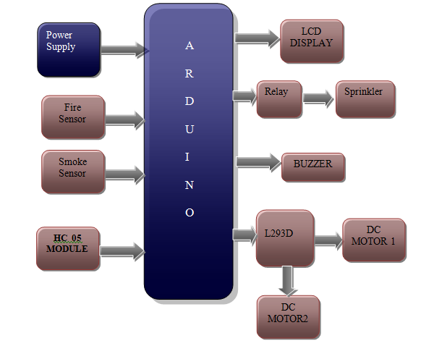
Fig.5.1.Block diagram

5.2 POWER SUPPLY:
All digital circuits require regulated power supply. In this article we are going to learn how to get a regulated positive supply from the mains supply.

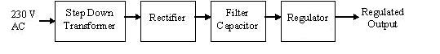
Fig:5.2.1 shows the basic block diagram of a fixed regulated power supply. Let us go through each block.
TRANSFORMER
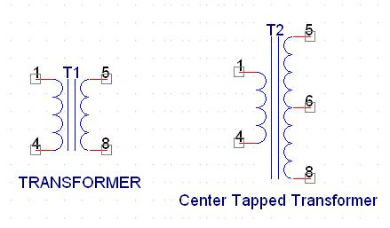
Figure 5.2.2 Transformer and Center Tapped Transformer
A transformer consists of two coils also called as “WINDINGS” namely PRIMARY & SECONDARY.
They are linked together through inductively coupled electrical conductors also called as CORE. A changing current in the primary causes a change in the Magnetic Field in the core & this in turn induces an alternating voltage in the secondary coil. If load is applied to the secondary then an alternating current will flow through the load. If we consider an ideal condition then all the energy from the primary circuit will be transferred to the secondary circuit through the magnetic field.
So 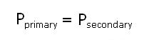
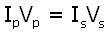

The secondary voltage of the transformer depends on the number of turns
in the Primary as well as in the secondary.
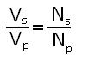
Rectifier
A rectifier is a device that converts an AC signal into DC signal. For rectification purpose we use a diode, a diode is a device that allows current to pass only in one direction i.e. when the anode of the diode is positive with respect to the cathode also called as forward biased condition & blocks current in the reversed biased condition.

Rectifier can be classified as follows:

1) Half Wave rectifier.
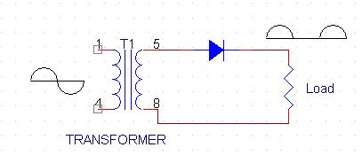
Figure 5.2.3 Half Wave rectifier

This is the simplest type of rectifier as you can see in the diagram a half wave rectifier consists of only one diode. When an AC signal is applied to it during the positive half cycle the diode is forward biased & current flows through it. But during the negative half cycle diode is reverse biased & no current flows through it. Since only one half of the input reaches the output, it is very inefficient to be used in power supplies.

2) Full wave rectifier.

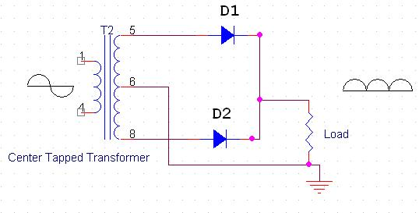
Figure 5.2.4 Full wave rectifier

Half wave rectifier is quite simple but it is very inefficient, for greater efficiency we would like to use both the half cycles of the AC signal. This can be achieved by using a center tapped transformer i.e. we would have to double the size of secondary winding & provide connection to the center. So during the positive half cycle diode D1 conducts & D2 is in reverse biased condition. During the negative half cycle diode D2 conducts & D1 is reverse biased. Thus we get both the half cycles across the load.
One of the disadvantages of Full Wave Rectifier design is the necessity of using a center tapped transformer, thus increasing the size & cost of the circuit. This can be avoided by using the Full Wave Bridge Rectifier.
3) BridgeRectifier.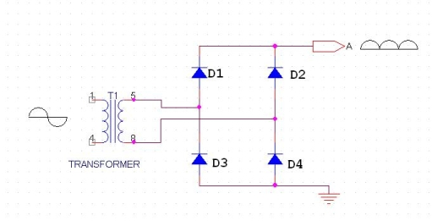
Figure 5.2.5 Bridge rectifier

As the name suggests it converts the full wave i.e. both the positive & the negative half cycle into DC thus it is much more efficient than Half Wave Rectifier & that too without using a center tapped transformer thus much more cost effective than Full Wave Rectifier.
Full Bridge Wave Rectifier consists of four diodes namely D1, D2, D3 and D4. During the positive half cycle diodes D1 & D4 conduct whereas in the negative half cycle diodes D2 & D3 conduct thus the diodes keep switching the transformer connections so we get positive half cycles in the output.
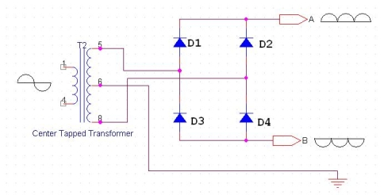
Figure 5.2.6 Bridge rectifier with positive and negative half cycles
If we use a center tapped transformer for a bridge rectifier we can get both positive & negative half cycles which can thus be used for generating fixed positive & fixed negative voltages.
FILTER CAPACITOR
Even though half wave & full wave rectifier give DC output, none of them provides a constant output voltage. For this we require to smoothen the waveform received from the rectifier. This can be done by using a capacitor at the output of the rectifier this capacitor is also called as “FILTER CAPACITOR” or “SMOOTHING CAPACITOR” or “RESERVOIR CAPACITOR”. Even after using this capacitor a small amount of ripple will remain.
We place the Filter Capacitor at the output of the rectifier the capacitor will charge to the peak voltage during each half cycle then will discharge its stored energy slowly through the load while the rectified voltage drops to zero, thus trying to keep the voltage as constant as possible.
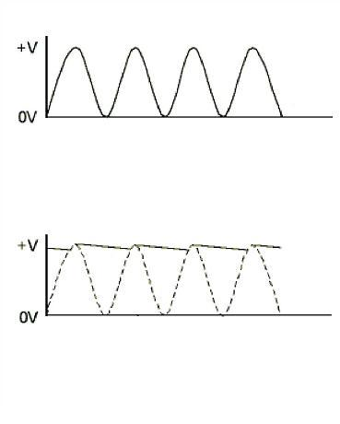
Figure 5.2.7 Filter Capacitor

If we go on increasing the value of the filter capacitor then the Ripple will decrease. But then the costing will increase. The value of the Filter capacitor depends on the current consumed by the circuit, the frequency of the waveform & the accepted ripple.
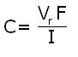

Where,
Vr= accepted ripple voltage.( should not be more than 10% of the voltage)
I= current consumed by the circuit in Amperes.
F= frequency of the waveform. A half wave rectifier has only one peak in one cycle so F=25hz
Whereas a full wave rectifier has Two peaks in one cycle so F=100hz.
VOLTAGE REGULATOR
A Voltage regulator is a device which converts varying input voltage into a constant regulated output voltage. Voltage regulator can be of two types
1) Linear Voltage Regulator
Also called as Resistive Voltage regulator because they dissipate the excessive voltage resistively as heat.
2) Switching Regulators.
They regulate the output voltage by switching the Current ON/OFF very rapidly. Since their output is either ON or OFF it dissipates very low power thus achieving higher efficiency as compared to linear voltage regulators. But they are more complex & generate high noise due to their switching action. For low level of output power switching regulators tend to be costly but for higher output wattage they are much cheaper than linear regulators.
The most commonly available Linear Positive Voltage Regulators are the 78XX series where the XX indicates the output voltage. And 79XX series is for Negative Voltage Regulators.
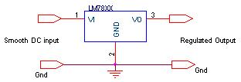
Figure 5.2.8 Voltage regulator

After filtering the rectifier output the signal is given to a voltage regulator. The maximum input voltage that can be applied at the input is 35V.Normally there is a 2-3 Volts drop across the regulator so the input voltage should be at least 2-3 Volts higher than the output voltage. If the input voltage gets below the Vmin of the regulator due to the ripple voltage or due to any other reason the voltage regulator will not be able to produce the correct regulated voltage.

Circuit diagram:
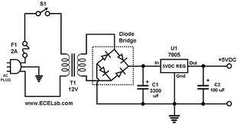
Fig 5.2.9. Circuit Diagram of power supply

IC 7805:
7805 is an integrated three-terminal positive fixed linear voltage regulator. It supports an input voltage of 10 volts to 35 volts and output voltage of 5 volts. It has a current rating of 1 amp although lower current models are available. Its output voltage is fixed at 5.0V. The 7805 also has a built-in current limiter as a safety feature. 7805 is manufactured by many companies, including National Semiconductors and Fairchild Semiconductors.
The 7805 will automatically reduce output current if it gets too hot.The last two digits represent the voltage; for instance, the 7812 is a 12-volt regulator. The 78xx series of regulators is designed to work in complement with the 79xx series of negative voltage regulators in systems that provide both positive and negative regulated voltages, since the 78xx series can't regulate negative voltages in such a system.
The 7805 & 78 is one of the most common and well-known of the 78xx series regulators, as it's small component count and medium-power regulated 5V make it useful for powering TTL devices.
Table 5.2.1. Specifications of IC7805
SPECIFICATIONS | IC 7805
V_{out} | 5V
V_{ein} - V_{out} Difference | 5V - 20V
Operation Ambient Temp | 0 - 125°C
Output I_{max} | 1A

5.3 LCD DISPLAY
LCD Background:
One of the most common devices attached to a micro controller is an LCD display. Some of the most common LCD’s connected to the many microcontrollers are 16x2 and 20x2 displays. This means 16 characters per line by 2 lines and 20 characters per line by 2 lines, respectively.

Basic 16x 2 Characters LCD
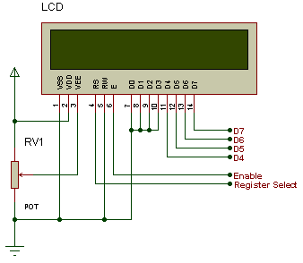
Figure 5.3.1: LCD Pin diagram

Pin description:
Pin No. | Name | Description
Pin no. 1 | VSS | Power supply (GND)
Pin no. 2 | VCC | Power supply (+5V)
Pin no. 3 | VEE | Contrast adjust
Pin no. 4 | RS | 0 = Instruction input  1 = Data input
Pin no. 5 | R/W | 0 = Write to LCD module  1 = Read from LCD module
Pin no. 6 | EN | Enable signal
Pin no. 7 | D0 | Data bus line 0 (LSB)
Pin no. 8 | D1 | Data bus line 1
Pin no. 9 | D2 | Data bus line 2
Pin no. 10 | D3 | Data bus line 3
Pin no. 11 | D4 | Data bus line 4
Pin no. 12 | D5 | Data bus line 5
Pin no. 13 | D6 | Data bus line 6
Pin no. 14 | D7 | Data bus line 7 (MSB)
Table 5.3.1: Character LCD pins with Microcontroller
The LCD requires 3 control lines as well as either 4 or 8 I/O lines for the data bus. The user may select whether the LCD is to operate with a 4-bit data bus or an 8-bit data bus. If a 4-bit data bus is used the LCD will require a total of 7 data lines (3 control lines plus the 4 lines for the data bus). If an 8-bit data bus is used the LCD will require a total of 11 data lines (3 control lines plus the 8 lines for the data bus).
The three control lines are referred to as EN, RS, and RW.
The EN line is called "Enable." This control line is used to tell the LCD that we are sending it data. To send data to the LCD, our program should make sure this line is low (0) and then set the other two control lines and/or put data on the data bus. When the other lines are completely ready, bring EN high (1) and wait for the minimum amount of time required by the LCD datasheet (this varies from LCD to LCD), and end by bringing it low (0) again.
The RS line is the "Register Select" line. When RS is low (0), the data is to be treated as a command or special instruction (such as clear screen, position cursor, etc.). When RS is high (1), the data being sent is text data which should be displayed on the screen. For example, to display the letter "T" on the screen we would set RS high.
The RW line is the "Read/Write" control line. When RW is low (0), the information on the data bus is being written to the LCD. When RW is high (1), the program is effectively querying (or reading) the LCD. Only one instruction ("Get LCD status") is a read command. All others are write commands--so RW will almost always be low.
Finally, the data bus consists of 4 or 8 lines (depending on the mode of operation selected by the user). In the case of an 8-bit data bus, the lines are referred to as DB0, DB1, DB2, DB3, DB4, DB5, DB6, and DB7.
Schematic:
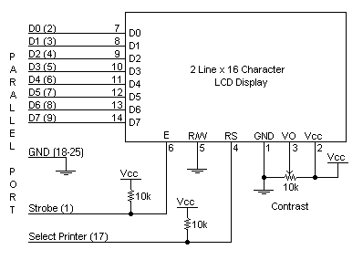
Figure 5.3.2: Schematic

Circuit Description:
Above is the quite simple schematic. The LCD panel's Enable and Register Select is connected to the Control Port. The Control Port is an open collector / open drain output. While most Parallel Ports have internal pull-up resistors, there is a few which don't. Therefore by incorporating the two 10K external pull up resistors, the circuit is more portable for a wider range of computers, some of which may have no internal pull up resistors.
We make no effort to place the Data bus into reverse direction. Therefore we hard wire the R/W line of the LCD panel, into write mode. This will cause no bus conflicts on the data lines. As a result we cannot read back the LCD's internal Busy Flag which tells us if the LCD has accepted and finished processing the last instruction. This problem is overcome by inserting known delays into our program.
The 10k Potentiometer controls the contrast of the LCD panel. Nothing fancy here. As with all the examples, I've left the power supply out. We can use a bench power supply set to 5v or use an onboard +5 regulator. Remember a few de-coupling capacitors, especially if we have trouble with the circuit working properly.
SETB RW
Handling the EN control line:
As we mentioned above, the EN line is used to tell the LCD that we are ready for it to execute an instruction that we've prepared on the data bus and on the other control lines. Note that the EN line must be raised/ lowered before/after each instruction sent to the LCD regardless of whether that instruction is read or write text or instruction. In short, we must always manipulate EN when communicating with the LCD. EN is the LCD's way of knowing that we are talking to it. If we don't raise/lower EN, the LCD doesn't know we're talking to it on the other lines.
Thus, before we interact in any way with the LCD we will always bring the EN line low with the following instruction:
CLR EN
And once we've finished setting up our instruction with the other control lines and data bus lines, we'll always bring this line high:
SETB EN
The line must be left high for the amount of time required by the LCD as specified in its datasheet. This is normally on the order of about 250 nanoseconds, but checks the datasheet. In the case of a typical microcontroller running at 12 MHz, an instruction requires 1.08 microseconds to execute so the EN line can be brought low the very next instruction. However, faster microcontrollers (such as the DS89C420 which executes an instruction in 90 nanoseconds given an 11.0592 MHz crystal) will require a number of NOPs to create a delay while EN is held high. The number of NOPs that must be inserted depends on the microcontroller we are using and the crystal we have selected.
The instruction is executed by the LCD at the moment the EN line is brought low with a final CLR EN instruction.
Checking the busy status of the LCD:
As previously mentioned, it takes a certain amount of time for each instruction to be executed by the LCD. The delay varies depending on the frequency of the crystal attached to the oscillator input of the LCD as well as the instruction which is being executed.
While it is possible to write code that waits for a specific amount of time to allow the LCD to execute instructions, this method of "waiting" is not very flexible. If the crystal frequency is changed, the software will need to be modified. A more robust method of programming is to use the "Get LCD Status" command to determine whether the LCD is still busy executing the last instruction received.
The "Get LCD Status" command will return to us two tidbits of information; the information that is useful to us right now is found in DB7. In summary, when we issue the "Get LCD Status" command the LCD will immediately raise DB7 if it's still busy executing a command or lower DB7 to indicate that the LCD is no longer occupied. Thus our program can query the LCD until DB7 goes low, indicating the LCD is no longer busy. At that point we are free to continue and send the next command.
Applications:
- Medical equipment
- Electronic test equipment
- Industrial machinery Interface
- Serial terminal
- Advertising system
- EPOS
- Restaurant ordering systems
- Gaming box
- Security systems
- R&D Test units
- Climatizing units
- PLC Interface
- Simulators
- Environmental monitoring
- Lab development
- Student projects
- Home automation
- PC external display
- HMI operator interface.

HC 05 MODULE:
The HC-05 is a very cool module which can add two-way (full-duplex) wireless functionality to your projects. You can use this module to communicate between two microcontrollers like Arduino or communicate with any device with Bluetooth functionality like a Phone or Laptop. There are many android applications that are already available which makes this process a lot easier. The module communicates with the help of USART at 9600 baud rate hence it is easy to interface with any microcontroller that supports USART. We can also configure the default values of the module by using the command mode. So if you looking for a Wireless module that could transfer data from your computer or mobile phone to microcontroller or vice versa then this module might be the right choice for you. However do not expect this module to transfer multimedia like photos or songs; you might have to look into the CSR8645 module for that.
How to Use the HC-05 Bluetooth module
The HC-05 has two operating modes, one is the Data mode in which it can send and receive data from other Bluetooth devices and the other is the AT Command mode where the default device settings can be changed. We can operate the device in either of these two modes by using the key pin as explained in the pin description.
It is very easy to pair the HC-05 module with microcontrollers because it operates using the Serial Port Protocol (SPP). Simply power the module with +5V and connect the Rx pin of the module to the Tx of MCU and Tx pin of module to Rx of MCU as shown in the figure below
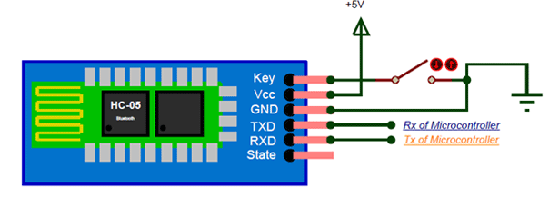
Figure 5.3.3 Bluetooth module
During power up the key pin can be grounded to enter into Command mode, if left free it will by default enter into the data mode. As soon as the module is powered you should be able to discover the Bluetooth device as “HC-05” then connect with it using the default password 1234 and start communicating with it. The name password and other default parameters can be changed by entering into the
Applications
1. Wireless communication between two microcontrollers
2. Communicate with Laptop, Desktops and mobile phones
3. Data Logging application
4. Consumer applications
5. Wireless Robots
6. Home Automation
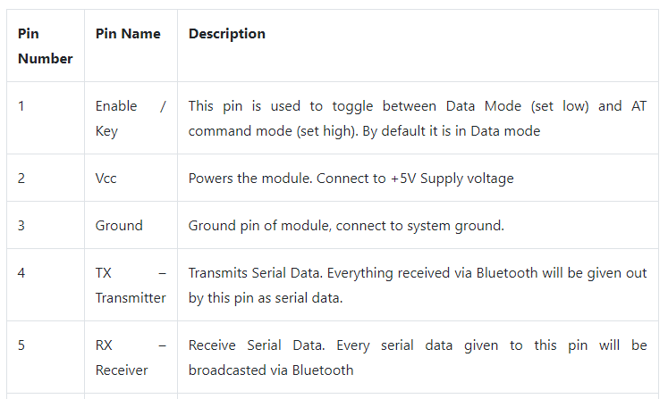
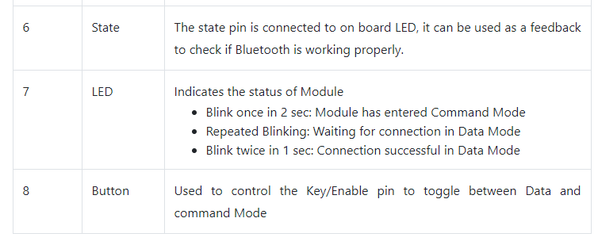
Table 5.3.2 Pin Description of Bluetooth Module:

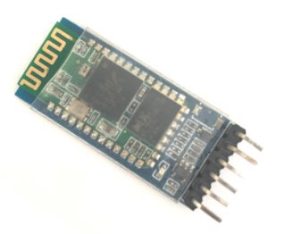
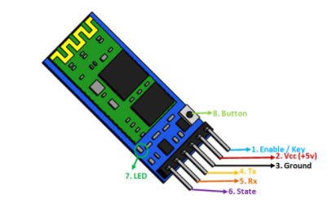
Figure 5.3.4 HC 05 module.

FIRE SENSOR:
A flame detector is a sensor designed to detect and respond to the presence of a flame or fire. Responses to a detected flame depend on the installation, but can include sounding an alarm, deactivating a fuel line (such as a propane or a natural gas line), and activating a fire suppression system.
There are different types of flame detection methods. Some of them are: Ultraviolet detector, near IR array detector, infrared (IR) detector, Infrared thermal cameras, UV/IR detector etc.

When fire burns it emits a small amount of Infra-red light, this light will be received by the Photodiode (IR receiver) on the sensor module. Then we use an Op-Amp to check for change in voltage across the IR Receiver, so that if a fire is detected the output pin (DO) will give 0V(LOW) and if the is no fire the output pin will be 5V(HIGH)
In this project we are using an IR based flame sensor. It is based on the YG1006 sensor which is a high speed and high sensitive NPN silicon phototransistor. It can detect infrared light with a wavelength ranging from 700nm to 1000nm and its detection angle is about 60°. Flame sensor module consists of a photodiode (IR receiver), resistor, capacitor, potentiometer, and LM393 comparator in an integrated circuit. The sensitivity can be adjusted by varying the on board potentiometer. Working voltage is between 3.3v and 5v DC, with a digital output.
Logic high on the output indicates presence of flame or fire. Logic low on output indicates absence of flame or fire.
Below is the Pin Description of Flame sensor Module:
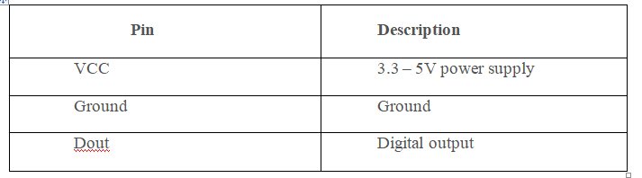
Table 5.3.3 Pin Description of Flame sensor Module:

Once you are ready with your hardware, you can upload the Arduino code for some action. The complete program is given at the end of this page. However I have further explained few important bits and pieces here.
As we know the fire sensor will output a HIGH when there is fire and will output a LOW when there is fire. So we have to keep checking these sensor if any fire has occurred.

GAS SENSOR:

Gas sensors need to be calibrated and periodically checked to ensure sensor accuracy and system integrity. It is important to install stationary sensors in locations where the calibration can be performed easily. The intervals between calibrations can be different from sensor to sensor. Generally, the manufacturer of the sensor will recommend a time interval between calibrations. However, it is good general practice to check the sensor more closely during the first 30 days after installation. During this period, it is possible to observe how well the sensor is adapting to its new environment. Also, factors that were not accounted for in the design of the system might surface and can affect the sensor’s performance.

If the sensor functions properly for 30 continuous days, this provides a good degree of confidence about the installation. Any possible problems can be identified and corrected during this time. Experience indicates that a sensor surviving 30 days after the initial installation will have a good chance of performing its function for the duration expected. Most problems—such as an inappropriate sensor location, interference from other gases, or the loss of sensitivity—will surface during this time.
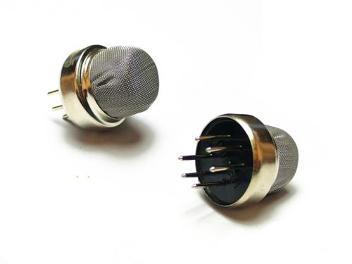
Fig5.3.5: Diagram of Gas sensor

Working of Gas sensor:
During the first 30 days, the sensor should be checked weekly. Afterward, a maintenance schedule, Hazardous Gas Monitors including calibration intervals, should be established. Normally, a monthly calibration is adequate to ensure the effectiveness and sensibility of each sensor; this monthly check will also afford you the opportunity to maintain the system’s accuracy. The method and procedure for calibrating the sensors should be established immediately. The calibration procedure should be simple, straightforward, and easily executed by regular personnel. Calibration here is simply a safety check, unlike laboratory analyzers that require a high degree of accuracy. For area air quality and safety gas monitors, the requirements need to be simple, repeatable, and economical. The procedure should be consistent and traceable. The calibration will be performed in the field where sensors are installed so it can occur in any type environment. Calibration of the gas sensor involves two steps. First the “zero” must be set and then the “span” must be calibrated.

The sensing material in TGS gas sensors is metal oxide, most typically SnO2. When a metal oxide Crystal such as SnO2 is heated at a certain high temperature in air, oxygen is adsorbed on the crystal surface with a negative charge. Then donor electrons in the crystal surface are transferred to the adsorbed oxygen, resulting in leaving positive charges in a space charge layer. Thus, surface potential is formed to serve as a potential barrier against electron flow.

Inside the sensor, electric current flows through the conjunction parts (grain boundary) of SnO2 micro crystals. At grain boundaries, adsorbed oxygen forms a potential barrier which prevents carriers from moving freely. The electrical resistance of the sensor is attributed to this potential barrier. In the presence of a deoxidizing gas, the surface density of the negatively charged oxygen decreases, so the barrier height in the grain boundary is reduced. The reduced barrier height decreases sensor resistance.

Sensor resistance will drop very quickly when exposed to gas, and when removed from gas its resistance will recover to its original value after a short time. The speed of response and reversibility will vary according to the model of sensor and the gas involved.

Feature
- Power requirements: 5 VDC @ ~160mA
- Interface Type: Resistive
- Dimensions: 0.75" diameter x 0.65" tall excluding leads (19.1mm diameter x 16.55mm tall excluding leads)
- Operating temp range: -4 to +122 °F (-20 to +50 °C)

Connections
connecting five volts across the heating (H) pins keeps the sensor hot enough to function correctly. Connecting five volts at either the A or B pins causes the sensor to emit an analog voltage on the other pins. A resistive load between the output pins and ground sets the sensitivity of the detector. Please note that the picture in the datasheet for the top configuration is wrong. Both configurations have the same pinout consistent with the bottom configuration. The resistive load should be calibrated for your particular application using the equations in the datasheet, but a good starting value for the resistor is 10 kΩ.
RELAY:
A relay is an electrically operated switch. It consists of a set of input terminals for a single or multiple control signals, and a set of operating contact terminals. The switch may have any number of contacts in multiple contact forms, such as make contacts, break contacts, or combinations thereof.
Relays are used where it is necessary to control a circuit by an independent low-power signal, or where several circuits must be controlled by one signal. Relays were first used in long-distance telegraph circuits as signal repeaters: they refresh the signal coming in from one circuit by transmitting it on another circuit. Relays were used extensively in telephone exchanges and early computers to perform logical operations.
The traditional form of a relay uses an electromagnet to close or open the contacts, but other operating principles have been invented, such as in solid-state relays which use semiconductor properties for control without relying on moving parts. Relays with calibrated operating characteristics and sometimes multiple operating coils are used to protect electrical circuits from overload or faults; in modern electric power systems these functions are performed by digital instruments still called protective relays.
Latching relays require only a single pulse of control power to operate the switch persistently. Another pulse applied to a second set of control terminals, or a pulse with opposite polarity, resets the switch, while repeated pulses of the same kind have no effects. Magnetic latching relays are useful in applications when interrupted power should not affect the circuits that the relay is controlling.
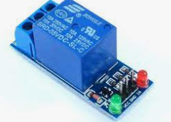
Fig5.3.6. Relay

L293D MOTOR DRIVER WITH MOTOR:
D.C. Motor:
A dc motor uses electrical energy to produce mechanical energy, very typically through the interaction of magnetic fields and current-carrying conductors. The reverse process, producing electrical energy from mechanical energy, is accomplished by an alternator, generator or dynamo. Many types of electric motors can be run as generators, and vice versa. The input of a DC motor is current/voltage and its output is torque (speed).

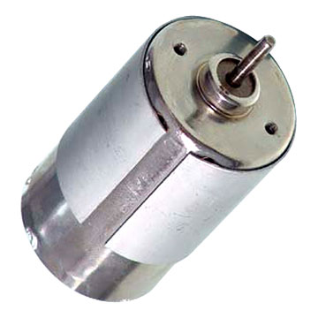
Fig 5.3.7 DC Motor
The DC motor has two basic parts: the rotating part that is called the armature and the stationary part that includes coils of wire called the field coils. The stationary part is also called the stator. Figure shows a picture of a typical DC motor, Figure shows a picture of a DC armature, and Fig shows a picture of a typical stator. From the picture you can see the armature is made of coils of wire wrapped around the core, and the core has an extended shaft that rotates on bearings. You should also notice that the ends of each coil of wire on the armature are terminated at one end of the armature. The termination points are called the commutator, and this is where the brushes make electrical contact to bring electrical current from the stationary part to the rotating part of the machine.
Operation:
The DC motor you will find in modem industrial applications operates very similarly to the simple DC motor described earlier in this chapter. Figure 12-9 shows an electrical diagram of a simple DC motor. Notice that the DC voltage is applied directly to the field winding and the brushes. The armature and the field are both shown as a coil of wire. In later diagrams, a field resistor will be added in series with the field to control the motor speed.
When voltage is applied to the motor, current begins to flow through the field coil from the negative terminal to the positive terminal. This sets up a strong magnetic field in the field winding. Current also begins to flow through the brushes into a commutator segment and then through an armature coil. The current continues to flow through the coil back to the brush that is attached to other end of the coil and returns to the DC power source. The current flowing in the armature coil sets up a strong magnetic field in the armature.

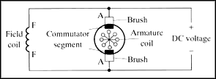

Fig 5.3.8 Simple electrical diagram of DC motor

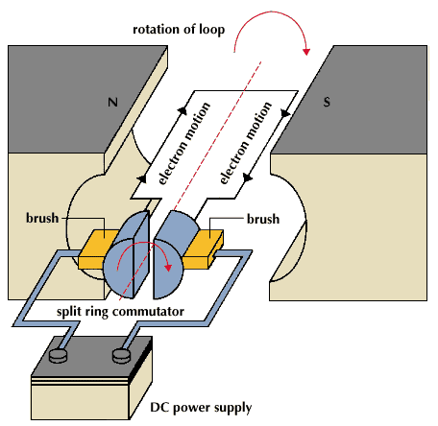
Fig 5.3.9 Operation of a DC Motor
The magnetic field in the armature and field coil causes the armature to begin to rotate. This occurs by the unlike magnetic poles attracting each other and the like magnetic poles repelling each other. As the armature begins to rotate, the commutator segments will also begin to move under the brushes. As an individual commutator segment moves under the brush connected to positive voltage, it will become positive, and when it moves under a brush connected to negative voltage it will become negative. In this way, the commutator segments continually change polarity from positive to negative. Since the commutator segments are connected to the ends of the wires that make up the field winding in the armature, it causes the magnetic field in the armature to change polarity continually from north pole to south pole. The commutator segments and brushes are aligned in such a way that the switch in polarity of the armature coincides with the location of the armature's magnetic field and the field winding's magnetic field. The switching action is timed so that the armature will not lock up magnetically with the field. Instead the magnetic fields tend to build on each other and provide additional torque to keep the motor shaft rotating.
When the voltage is de-energized to the motor, the magnetic fields in the armature and the field winding will quickly diminish and the armature shaft's speed will begin to drop to zero. If voltage is applied to the motor again, the magnetic fields will strengthen and the armature will begin to rotate again.
Types of DC motors:
1. DC Shunt Motor,
2. DC Series Motor,
3. DC Long Shunt Motor (Compound)
4. DC Short Shunt Motor (Compound)
The rotational energy that you get from any motor is usually the battle between two magnetic fields chasing each other. The DC motor has magnetic poles and an armature, to which DC electricity is fed, The Magnetic Poles are electromagnets, and when they are energized, they produce a strong magnetic field around them, and the armature which is given power with a commutator, constantly repels the poles, and therefore rotates.
1. The DC Shunt Motor:
In a 2 pole DC Motor, the armature will have two separate sets of windings, connected to a commutator at the end of the shaft that are in constant touch with carbon brushes. The brushes are static, and the commutator rotate and as the portions of the commutator touching the respective positive or negative polarity brush will energize the respective part of the armature with the respective polarity. It is usually arranged in such a way that the armature and the poles are always repelling.
The general idea of a DC Motor is, the stronger the Field Current, the stronger the magnetic field, and faster the rotation of the armature. When the armature revolves between the poles, the magnetic field of the poles induce power in the armature conductors, and some electricity is generated in the armature, which is called back emf, and it acts as a resistance for the armature. Generally an armature has resistance of less than 1 Ohm, and powering it with heavy voltages of Direct Current could result in immediate short circuits. This back emf helps us there.
When an armature is loaded on a DC Shunt Motor, the speed naturally reduces, and therefore the back emf reduces, which allows more armatures current to flow. This results in more armature field, and therefore it results in torque.
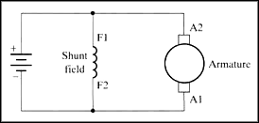
Fig 5.3.10: Diagram of DC shunt motor
When a DC Shunt Motor is overloaded, if the armature becomes too slow, the reduction of the back emf could cause the motor to burn due to heavy current flow thru the armature.
The poles and armature are excited separately, and parallel, therefore it is called a Shunt Motor.
2. The DC Series Motor:
Fig5.3.11 Diagram of DC series motor
A DC Series Motor has its field coil in series with the armature. Therefore any amount of power drawn by the armature will be passed thru the field. As a result you cannot start a Series DC Motor without any load attached to it. It will either run uncontrollably in full speed, or it will stop.
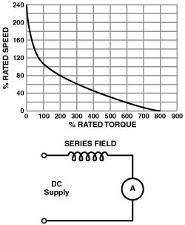
Fig5.3.11 Diagram of DC series motor graph representation
When the load is increased then its efficiency increases with respect to the load applied. So these are on Electric Trains and elevators.
3. DC Compound Motor:
A compound of Series and Shunt excitation for the fields is done in a Compound DC Motor. This gives the best of both series and shunt motors. Better torque as in a series motor, while the possibility to start the motor with no load.
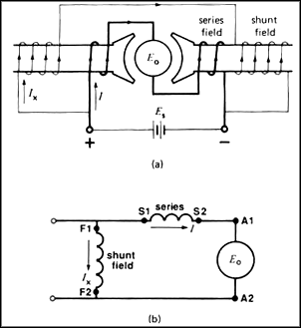
Fig 5.3.12 Diagram of DC compound motor
Above is the diagram of a long shunt motor, while in a short shunt, the shunt coil will be connected after the serial coil.
A Compound motor can be run as a shunt motor without connecting the serial coil at all but not vice versa.
DC Motor Driver:

The L293 and L293D are quadruple high-current half-H drivers. The L293 is designed to provide bidirectional drive currents of up to 1 A at voltages from 4.5 V to 36 V. The L293D is designed to provide bidirectional drive currents of up to 600-mA at voltages from 4.5 V to 36 V. Both devices are designed to drive inductive loads such as relays, solenoids, dc and bipolar stepping motors, as well as other high-current/high-voltage loads in positive-supply applications.
All inputs are TTL compatible. Each output is a complete totem-pole drive circuit, with a Darlington transistor sink and a pseudo-Darlington source. Drivers are enabled in pairs, with drivers 1 and 2 enabled by 1,2EN and drivers 3 and 4 enabled by 3,4EN.When an enable input is high, the associated drivers are enabled and their outputs are active and in phase with their inputs.

When the enable input is low, those drivers are disabled and their outputs are off and in the high-impedance state. With the proper data inputs, each pair of drivers forms a full-H (or bridge) reversible drive suitable for solenoid or motor applications. On the L293, external high-speed output clamp diodes should be used for inductive transient suppression. A VCC1 terminal, separate from VCC2, is provided for the logic inputs to minimize device power dissipation. The L293and L293D are characterized for operation from 0°C to 70°C.

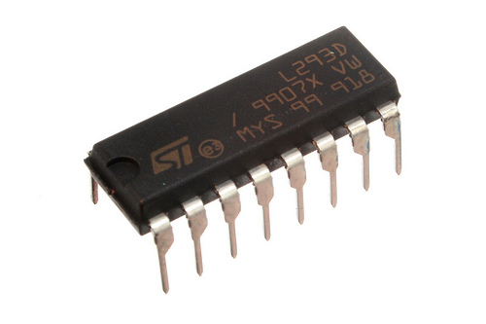
Fig 5.3.13: L293D IC
Pin Diagram of L293D motor driver:
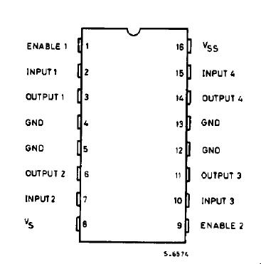
Fig 5.3.14: L293D pin diagram
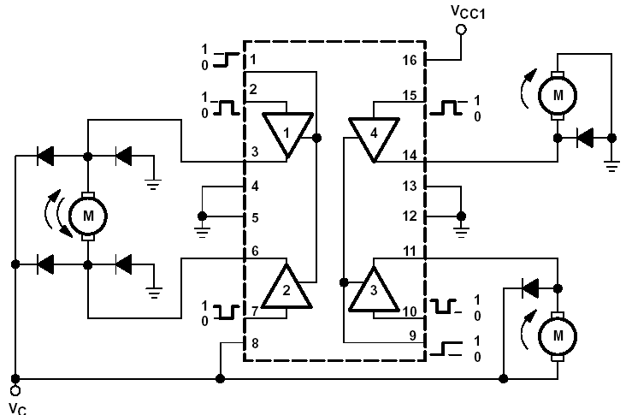
Fig 5.3.15: Internal structure of L293D.

Features of L293D:
- 600mA Output current capability per channel
- 1.2A Peak output current (non repetitive) per channel
- Enable facility
- Over temperature protection
- Logical “0”input voltage up to 1.5 v
- High noise immunity
- Internal clamp diodes
Applications of DC Motors:
1. Electric Train: A kind of DC motor called the DC Series Motor is used in Electric Trains. The DC Series Motors have the property to deliver more power when they are loaded more. So the more the people get on a train, the more powerful the train becomes.
2. Elevators: The best bidirectional motors are DC motors. They are used in elevators. Compound DC Motors are used for this application.
3. PC Fans, CD ROM Drives, and Hard Drives: All these things need motors, very miniature motors, with great precision. AC motors can never imagine any application in these places.
4. Starter Motors in Automobiles: An automobile battery supplies DC, so a DC motor is best suited here. Also, you cannot start an engine with a small sized AC motor,
5. Electrical Machines Lab in Colleges.

CHAPTER-6
ARDUINO CONTROLLER
Arduino is an open-source hardware and software company, project and user community that designs and manufactures single-board microcontrollers and microcontroller kits for building digital devices and interactive objects that can sense and control both physically and digitally. Its products are licensed under the GNU Lesser General Public License (LGPL) or the GNU General Public License (GPL), permitting the manufacture of Arduino boards and software distribution by anyone. Arduino boards are available commercially in preassembled form or as do-it-yourself (DIY) kits.
Arduino board designs use a variety of microprocessors and controllers. The boards are equipped with sets of digital and analog input/output (I/O) pins that may be interfaced to various expansion boards or breadboards (shields) and other circuits. The boards feature serial communications interfaces, including Universal Serial Bus (USB) on some models, which are also used for loading programs from personal computers. The microcontrollers are typically programmed using a dialect of features from the programming languages C and C++. In addition to using traditional compiler toolchains, the Arduino project provides an integrated development environment (IDE) based on the Processing language project.
The Arduino project started in 2003 as a program for students at the Interaction Design Institute Ivrea in Ivrea, Italy, aiming to provide a low-cost and easy way for novices and professionals to create devices that interact with their environment using sensors and actuators. Common examples of such devices intended for beginner hobbyists include simple robots, thermostats and motion detectors.
The name Arduino comes from a bar in Ivrea, Italy, where some of the founders of the project used to meet. The bar was named after Arduin of Ivrea, who was the margrave of the March of Ivrea and King of Italy from 1002 to 1014.
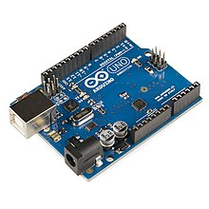
Fig.6.1. Hardware image.
History:
The Arduino project was started at the Interaction Design Institute Ivrea (IDII) in Ivrea, Italy.^{[2]} At that time, the students used a BASIC Stamp microcontroller at a cost of $50, a considerable expense for many students. In 2003 Hernando Barragán created the development platform Wiring as a Master's thesis project at IDII, under the supervision of Massimo Banzi and Casey Reas. Casey Reas is known for co-creating, with Ben Fry, the Processing development platform. The project goal was to create simple, low cost tools for creating digital projects by non-engineers. The Wiring platform consisted of a printed circuit board (PCB) with an ATmega168 microcontroller, an IDE based on Processing and library functions to easily program the microcontroller.^{[4]} In 2003, Massimo Banzi, with David Mellis, another IDII student, and David Cuartielles, added support for the cheaper ATmega8 microcontroller to Wiring. But instead of continuing the work on Wiring, they forked the project and renamed it Arduino.
The initial Arduino core team consisted of Massimo Banzi, David Cuartielles, Tom Igoe, Gianluca Martino, and David Mellis,^{[2]} but Barragán was not invited to participate.
Following the completion of the Wiring platform, lighter and less expensive versions were distributed in the open-source community.
It was estimated in mid-2011 that over 300,000 official Arduinos had been commercially produced, and in 2013 that 700,000 official boards were in users' hands. In October 2016, Federico Musto, Arduino's former CEO, secured a 50% ownership of the company. In April 2017, Wired reported that Musto had "fabricated his academic record.... On his company's website, personal LinkedIn accounts, and even on Italian business documents, Musto was until recently listed as holding a PhD from the Massachusetts Institute of Technology. In some cases, his biography also claimed an MBA from New York University." Wired reported that neither University had any record of Musto's attendance, and Musto later admitted in an interview with Wired that he had never earned those degrees. Around that same time, Massimo Banzi announced that the Arduino Foundation would be "a new beginning for Arduino." But a year later, the Foundation still hasn't been established, and the state of the project remains unclear. The controversy surrounding Musto continued when, in July 2017, he reportedly pulled many Open source licenses, schematics, and code from the Arduino website, prompting scrutiny and outcry. In October 2017, Arduino announced its partnership with ARM Holdings (ARM). The announcement said, in part, "ARM recognized independence as a core value of Arduino ... without any lock-in with the ARM architecture.” Arduino intends to continue to work with all technology vendors and architectures.
OPERATION WITH PINS:
Arduino is open-source hardware. The hardware reference designs are distributed under a Creative Commons Attribution Share-Alike 2.5 license and are available on the Arduino website. Layout and production files for some versions of the hardware are also available.
Although the hardware and software designs are freely available under copyleft licenses, the developers have requested the name Arduino to be exclusive to the official product and not be used for derived works without permission. The official policy document on use of the Arduino name emphasizes that the project is open to incorporating work by others into the official product. Several Arduino-compatible products commercially released have avoided the project name by using various names ending in -duino.
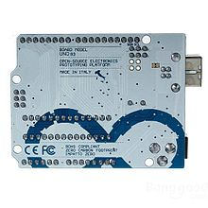
Fig.6.2. Back side of module.
Most Arduino boards consist of an Atmel 8-bit AVR microcontroller (ATmega8,[24] ATmega168, ATmega328, ATmega1280, ATmega2560) with varying amounts of flash memory, pins, and features. The 32-bit Arduino Due, based on the Atmel SAM3X8E was introduced in 2012. The boards use single or double-row pins or female headers that facilitate connections for programming and incorporation into other circuits. These may connect with add-on modules termed shields. Multiple and possibly stacked shields may be individually addressable via an I²C serial bus. Most boards include a 5 V linear regulator and a 16 MHz crystal oscillator or ceramic resonator. Some designs, such as the LilyPad, run at 8 MHz and dispense with the onboard voltage regulator due to specific form-factor restrictions.
Arduino microcontrollers are pre-programmed with a boot loader that simplifies uploading of programs to the on-chip flash memory. The default bootloader of the Arduino UNO is the optiboot bootloader. Boards are loaded with program code via a serial connection to another computer. Some serial Arduino boards contain a level shifter circuit to convert between RS-232 logic levels and transistor–transistor logic (TTL) level signals. Current Arduino boards are programmed via Universal Serial Bus (USB), implemented using USB-to-serial adapter chips such as the FTDI FT232. Some boards, such as later-model Uno boards, substitute the FTDI chip with a separate AVR chip containing USB-to-serial firmware, which is reprogrammable via its own ICSP header. Other variants, such as the Arduino Mini and the unofficial Boarduino, use a detachable USB-to-serial adapter board or cable, Bluetooth or other methods. When used with traditional microcontroller tools, instead of the Arduino IDE, standard AVR in-system programming (ISP) programming is used. The Arduino board exposes most of the microcontroller's I/O pins for use by other circuits. The Diecimila,[a] Duemilanove,[b] and current Uno[c] provide 14 digital I/O pins, six of which can produce pulse-width modulated signals, and six analog inputs, which can also be used as six digital I/O pins. These pins are on the top of the board, via female 0.1-inch (2.54 mm) headers. Several plug-in application shields are also commercially available. The Arduino Nano, and Arduino-compatible Bare Bones Board and Boarduino boards may provide male header pins on the underside of the board that can plug into solderless breadboards.
Many Arduino-compatible and Arduino-derived boards exist. Some are functionally equivalent to an Arduino and can be used interchangeably. Many enhance the basic Arduino by adding output drivers, often for use in school-level education, to simplify making buggies and small robots. Others are electrically equivalent but change the form factor, sometimes retaining compatibility with shields, sometimes not. Some variants use different processors, of varying compatibility.
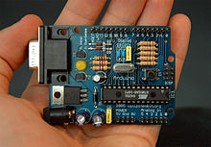
Fig.6.3. Ardino board.
  - Power USB
Arduino board can be powered by using the USB cable from your computer. All you need to do is connect the USB cable to the USB connection (1).
 | Power (Barrel Jack)  Arduino boards can be powered directly from the AC mains power supply by connecting it to the Barrel Jack (2).
 | Voltage Regulator  The function of the voltage regulator is to control the voltage given to the Arduino board and stabilize the DC voltages used by the processor and other elements.
 | Crystal Oscillator  The crystal oscillator helps Arduino in dealing with time issues. How does Arduino calculate time? The answer is, by using the crystal oscillator. The number printed on top of the Arduino crystal is 16.000H9H. It tells us that the frequency is 16,000,000 Hertz or 16 MHz.
 | Arduino Reset  You can reset your Arduino board, i.e., start your program from the beginning. You can reset the UNO board in two ways. First, by using the reset button (17) on the board. Second, you can connect an external reset button to the Arduino pin labelled RESET (5).
 | Pins (3.3, 5, GND, Vin)  - 3.3V (6) − Supply 3.3 output volt  - 5V (7) − Supply 5 output volt  - Most of the components used with Arduino board works fine with 3.3 volt and 5 volt.  - GND (8)(Ground) − There are several GND pins on the Arduino, any of which can be used to ground your circuit.  - Vin (9) − This pin also can be used to power the Arduino board from an external power source, like AC mains power supply.
 | Analog pins  The Arduino UNO board has six analog input pins A0 through A5. These pins can read the signal from an analog sensor like the humidity sensor or temperature sensor and convert it into a digital value that can be read by the microprocessor.
 | Main microcontroller  Each Arduino board has its own microcontroller (11). You can assume it as the brain of your board. The main IC (integrated circuit) on the Arduino is slightly different from board to board. The microcontrollers are usually of the ATMEL Company. You must know what IC your board has before loading up a new program from the Arduino IDE. This information is available on the top of the IC. For more details about the IC construction and functions, you can refer to the data sheet.
 | ICSP pin  Mostly, ICSP (12) is an AVR, a tiny programming header for the Arduino consisting of MOSI, MISO, SCK, RESET, VCC, and GND. It is often referred to as an SPI (Serial Peripheral Interface), which could be considered as an "expansion" of the output. Actually, you are slaving the output device to the master of the SPI bus.
 | Power LED indicator  This LED should light up when you plug your Arduino into a power source to indicate that your board is powered up correctly. If this light does not turn on, then there is something wrong with the connection.
 | TX and RX LEDs  On your board, you will find two labels: TX (transmit) and RX (receive). They appear in two places on the Arduino UNO board. First, at the digital pins 0 and 1, to indicate the pins responsible for serial communication. Second, the TX and RX led (13). The TX led flashes with different speed while sending the serial data. The speed of flashing depends on the baud rate used by the board. RX flashes during the receiving process.
 | Digital I/O  The Arduino UNO board has 14 digital I/O pins (15) (of which 6 provide PWM (Pulse Width Modulation) output. These pins can be configured to work as input digital pins to read logic values (0 or 1) or as digital output pins to drive different modules like LEDs, relays, etc. The pins labeled “~” can be used to generate PWM.
 | AREF  AREF stands for Analog Reference. It is sometimes, used to set an external reference voltage (between 0 and 5 Volts) as the upper limit for the analog input pins.
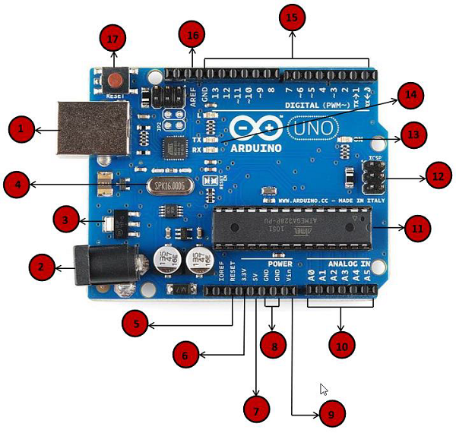
Fig.6.4. Pin explanation.

CHAPTER-7
SOFTWARE EXPLANATION
7.1: Introduction
This project is implemented using following software’s:
    - Express PCB – for designing circuit
    - Arduino IDE compiler - for compilation part
    - Proteus 7 (Embedded C) – for simulation part

7.2: The Interface

When a project is first started you will be greeted with a yellow outline. This yellow outline is the dimension of the PCB. Typically after positioning of parts and traces, move them to their final position and then crop the PCB to the correct size. However, in designing a board with a certain size constraint, crop the PCB to the correct size before starting.

Fig: 7.2.1 show the toolbar in which the each button has the following functions:

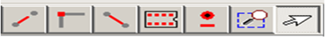

Fig: 7.2.1 Tool bar necessary for the interface

The select tool: It is fairly obvious what this does. It allows you to move and manipulate parts. When this tool is selected the top toolbar will show buttons to move traces to the top / bottom copper layer, and rotate buttons.
The zoom to selection tool: does just that.

The place pad: button allows you to place small soldier pads which are useful for board connections or if a part is not in the part library but the part dimensions are available. When this tool is selected the top toolbar will give you a large selection of round holes, square holes and surface mount pads.
The place component: tool allows you to select a component from the top toolbar and then by clicking in the workspace places that component in the orientation chosen using the buttons next to the component list. The components can always be rotated afterwards with the select tool if the orientation is wrong.

The place trace: tool allows you to place a solid trace on the board of varying thicknesses. The top toolbar allows you to select the top or bottom layer to place the trace on.

The Insert Corner in trace: button does exactly what it says. When this tool is selected, clicking on a trace will insert a corner which can be moved to route around components and other traces.

The remove a trace button is not very important since the delete key will achieve the same result.

7.3: Design Considerations

Before starting a project there are several ways to design a PCB and one must be chosen to suit the project’s needs. Single sided, or double sided?

When making a PCB you have the option of making a single sided board, or a double sided board. Single sided boards are cheaper to produce and easier to etch, but much harder to design for large projects. If a lot of parts are being used in a small space it may be difficult to make a single sided board without jumpering over traces with a cable. While there’s technically nothing wrong with this, it should be avoided if the signal travelling over the traces is sensitive (e.g. audio signals).

A double sided board is more expensive to produce professionally, more difficult to etch on a DIY board, but makes the layout of components a lot smaller and easier. It should be noted that if a trace is running on the top layer, check with the components to make sure you can get to its pins with a soldering iron. Large capacitors, relays, and similar parts which don’t have axial leads can NOT have traces on top unless boards are plated professionally.

7.4 AURDINO COMPILING

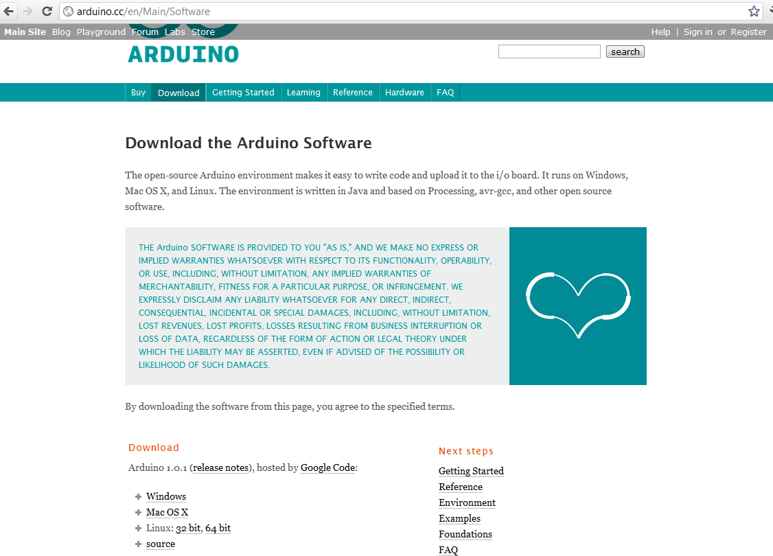
In next step download library

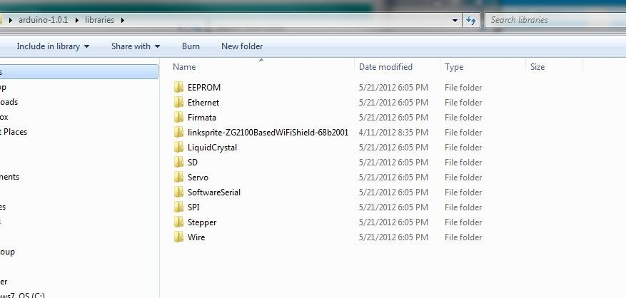

As Arduino doesn’t recognize the directory name, please rename it

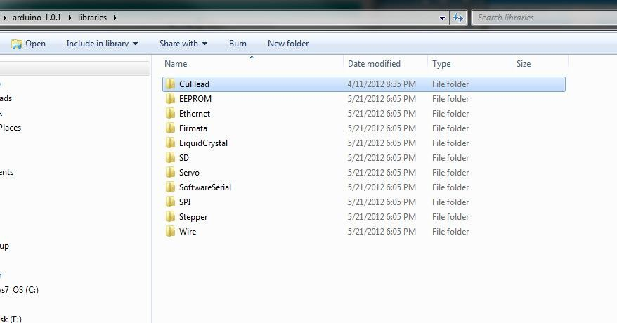

Launch Arduino by double click “Arduino” below
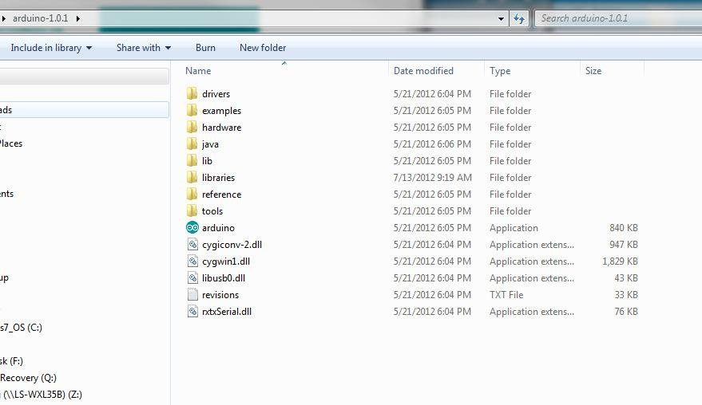
One example
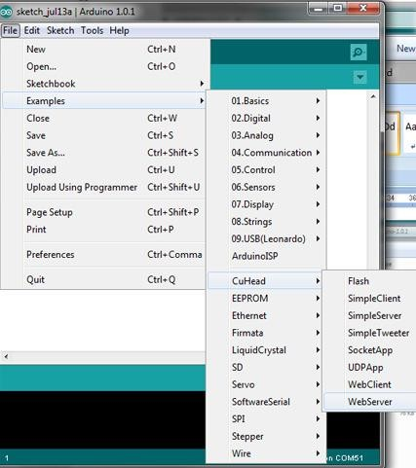

Select the target board as “Arduino Uno”:

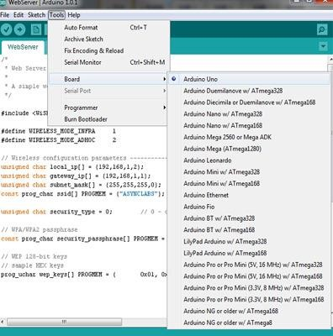
Click Sketch-> Verify/Compile:
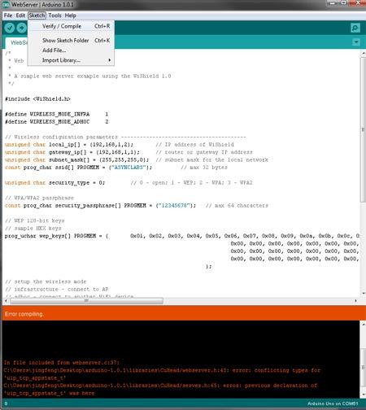
CHAPTER-8
METHODOLOGY WITH WORKING
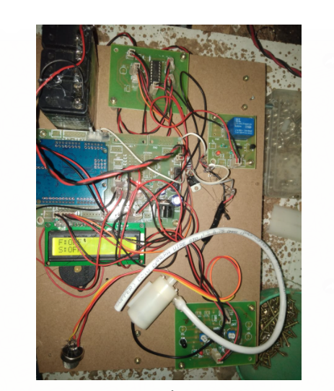
Fig.8.1. Hardware kit image.
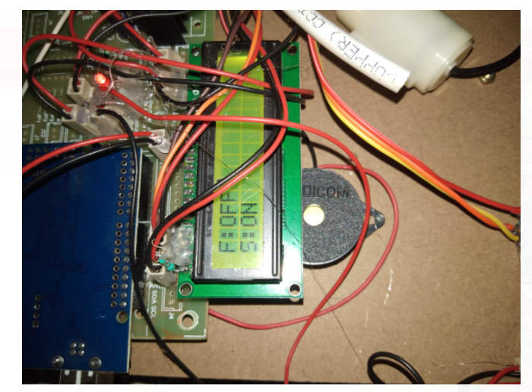
Fig.8.2. Smoke sensor detected time
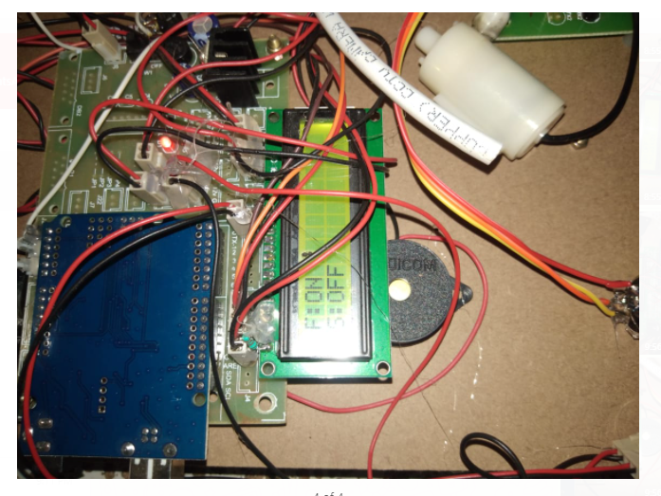
Fig.8.3. Fire sensor detected indication.
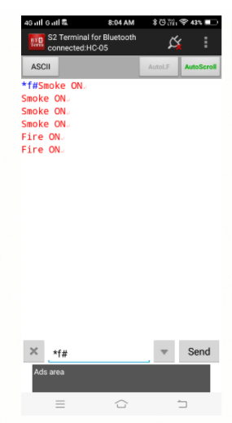

CHAPTER-9
ADVANTAGES AND LIMITATIONS
ADVANTAGES:
- Easily track the missile.
- To easily disposal of missile.
- Buzzer indications also get here.
- WSN also possible here.
APPLICATIONS:
- Can be used in server rooms.
- Extinguishes fire where probability of explosion is high.
- Usable in Power plant control rooms, Captain bridges, Flight control centers.
- Disaster area monitoring and rescue.
- By inventing such a device, humans as well as property can be saved at higher rate with minimum damage caused by the fire.
- As instrumentation engineers, our task was to design and build a prototype system that could autonomously detect and extinguish a fire and also aims at minimizing the air pollution.
- The possibilities of fire are at any remote area or in an industry such as in garments go down, cotton mills, and fuel storage tanks, electric leakages may result in terrible fire & harm.
- The robot could be used to enter small spaces that are impossible to be accessed by a person.

CHAPTER-10
CONCLUSION
CONCLUSION:
In many places such as schools, colleges our proposed project aims to develop an Arduino controlled fire fighter robot that can be used to extinguish fires through remote handling. By this we can avoid Fire accidents and also prevent manual intervention of fire extinguishing. We have tested it properly. The security system of the home and building contains firefighting robot security vehicle, F module. The main controller of the firefighting robot is a microcontroller. We programmed the microcontroller to control the robotic vehicle to acquire flame sensor data, and run the vehicle towards fire by giving directions using commands given through the android mobile. Once the flame is detected by flame sensor, buzzer is activated. The water pump is activated in automatic mode. The robot is highly intelligent and likely able to be extended to a wider-range of applications and scenarios. Smoke detectors that set off fire alarms could be used to initiate the sound-activated robot. Pre-programming the robot with a floor plan and room locations would make it easy to find and extinguish a fire before humans are even aware of the situation. Many of the methods used in this project, specifically in the navigation aspect, are still under research and development. Anyone interested in coming up with possible improvements could write their own algorithms given some programming experience in C++ and/or Python. It may be very challenging or even impossible to improve performance. There are smaller, lighter, microcontroller based robots, and are capable of very high speeds. But our robot is a versatile platform that could be used even just as a tool for navigation algorithm development.
FUTURE SCOPE:
Some of interfacing applications which can be made are controlling home appliances, robotics movements, Speech Assisted technologies etc. By making it GPS enabled, robot can be controlled from remote station also. A CO2 booster can be attached to make it powerful extinguisher. In the present condition it can extinguish fire only in the way and not in all the rooms. It can be extended to a real fire extinguisher by replacing the fan by a carbon-di-oxide carrier and by making it to extinguish fires of all the room using microprogramming. Also the robot could not be run through the batteries because at some conditions the current requirement for the circuit rises to about .8A which is very high and cannot be obtained using batteries. So we will try to develop the robot with many useful features like adding video camera, improvement in battery capacity, improvement in high weight etc...

CHAPTER-11
BIBLIOGRAPHY
REFERENCE :
[1] Aliff, M., S. Dohta, and T. Akagi, Simple Trajectory Control Method of Robot Arm Using Flexible Pneumatic Cylinders. Journal of Robotics and Mechatronics, 2015. 27(6): p. 698-705
[2] H. Hyung, B. Ahn, B. Cruz and D. Lee, Analysis of android robot lip-sync factors affecting communication, 11th ACM/IEEE International Conference on Human-Robot Interaction (HRI), 2016, pp. 441-442
[3] Bradshaw, 1991"The UK Security and Fire Fighting Advanced Robot Project," IEE colloquium on advanced robotic initiatives in the UK, pp.1/1-1/4
[4] T. Aprille and T. Trick., “Steady-state analysis of nonlinear circuits with periodic inputs”, Proceedings of the IEEE, vol. 60, no. 1, pp. 108-114, January 1972.
[5] Preeti Dhiman, Noble Tawra, Rakesh Nagar, Rishab Singh and Varun Kaushik, “Voice Operated Intelligent Fire Extinguisher Vehicle”, International Journal of Emerging Trends in Electrical and Electronics (IJETEE) Vol. 2, No.2, pp. 43-47, April-2013.
[6] Rutuja Jadkar, Rutuja Wadekar, Shweta Khatade, Sayali Dugane, Prof. Dr.S.N. Kini, Fire Fighting Robot Controlled Using Android Application, International Journal of Innovative Research in Science, Engineering and Technology, Vol. 5, Issue 5, May 2016.
[7] O. Parlaktuna, E. Eroğlu, Gezgin Robotlarda Ultrasonik Mesafe Algılayıcılarla Robot Davranışlarının Kontrolü ve Çevre Haritalama, Eskişehir Osmangazi University Journal of Engineering and Architecture, 2(5), 2007, 83-106.
[8] P.Karthikeyan, M.Suresh, K.Bharathi, U.Keerthana and D.Vinuprakash, “ Lab View based speed control of Single Phase Induction motor by V/f control method” in International Journal for Scientific Research and Development, Vol.5, No.12, pp: 1151-1154, March 2018.
[9] Sija Gopinathan, Athira Krishnan R, Renu Tony, Vishnu M. and Yedhukrishnan, “Wireless Voice Controlled Fire Extinguisher Robot” in International Journal of Advanced Research in Electrical, Electronics and Instrumentation Engineering Vol.4, No.4, pp. 2483-87, April 2015.
[10] T. L. Chien, H. Guo, K. L. Su, and S. V. Shiau, Develop a multiple interface based firefighting robot, In 2007 IEEE International Conference on Mechatronics, IEEE, 2007, 1-6.
[11] Kristi Kosasis, E.Merry Sartika, M. Jimmy Hasugian, Dan Muliady (2010) The Intelligent Fire Fighting Tank Robot Electrical Engineering Journal Vol.No. 1, pp. 73-80 (PDF).

